**A mini-project report on**

**AUTOMATIC AND REMOTE HANDLING LED SYSTEM**

*submitted in partial fulfillment of the*

*requirements for*

**TE (Information Technology)**

*by*

**Mr. Kazi Jawwad A Rahim (T-16-0020)**

**Mr. Kiratkar Gunjan Narayan (T-16-0080)**

**Ms. Ghogale Sonali Sudhakar ( T-16-0212)**

**…………………**

*under the guidance of*

**Prof. Amar Palwankar**



Department of Information Technology

Finolex Academy of Management and Technology, Ratnagiri

October 2018

**Objective :**

1.To study the Intel Edison Board.

2.To study and implemented remote and automatic led blinking using intel Edison and light Sensor .

3.To understand how the light sensor and cloud works.

**Pre-requisites :**

1. Prior knowledge of Python Programming Langauge.

2.Knowledge about Intel Edison Board.

3.Knowledge about Light sensor.

4.Windows system with Arduino IDE, installed.

5.Knowledge about Different Types of Clouds.

**Technology and Tools Used:**

1. Arduino IDE compiler
2. Light sensor
3. LED
4. Wires
5. Intel Edison Board

**Project Plan:**

1.Planning resources required for project.

2.Planning for different modules.

3. Selecting libraries for implementation.

4, Shedulling of tasks.

5, assigning roles.

**Testing :**

We have tested our program over Arduino IDE.

**Results :**

**Code:**

import mraa

import time

from ubidots import ApiClient

LED_AIO = 0

LED_GPIO=13

sensor = mraa.Aio(LED_AIO)

global blinkLed=mraa.Gpio(LED_GPIO)

blinkLed.dir(mraa.DIR_OUT)

blinkLed.write(0)

global touchVar = "5baf2fccc03f9763183vv718"

global touchValue = api.get_variable(touchVar)

global onboard_led = mraa.Gpio(13)

onboard_led.dir(mraa.DIR_OUT)

def ubidots():

try:

print "Requesting Ubidots token"

api = ApiClient('A1E-cebf753ff62fb3dad9faa52b6d5da6b2bc82')

except:

print "No internet connection, retrying..."

time.sleep(2)

sys.exit(0)

touchValue = api.get_variable(touchVar)

onboard_led.dir(mraa.DIR_OUT)

last_value = touchValue.get_values(1)

touch_value = int(last_value[0]['value'])

print "Last value of touch variable ",touch_value

if(touch_value==1):

onboard_led.write(1)

time.sleep(1)

else:

onbloard_led.write(0)

time.sleep(1)

def regular():

v=sensor.read()

if v<=150:

blinkLed.write(1)

else:

binkLed.write(0)

time.sleep(1)

while(1):

v=input("Enter the choice\n1.Ubidots\n2.Regular\n")

if(v==1):

ubidots()

elif(v==2):

regular()

else:

print("Invalid Choice\n")

**Output:**

1. Select Option :

1)Ubidots

2)Sensor

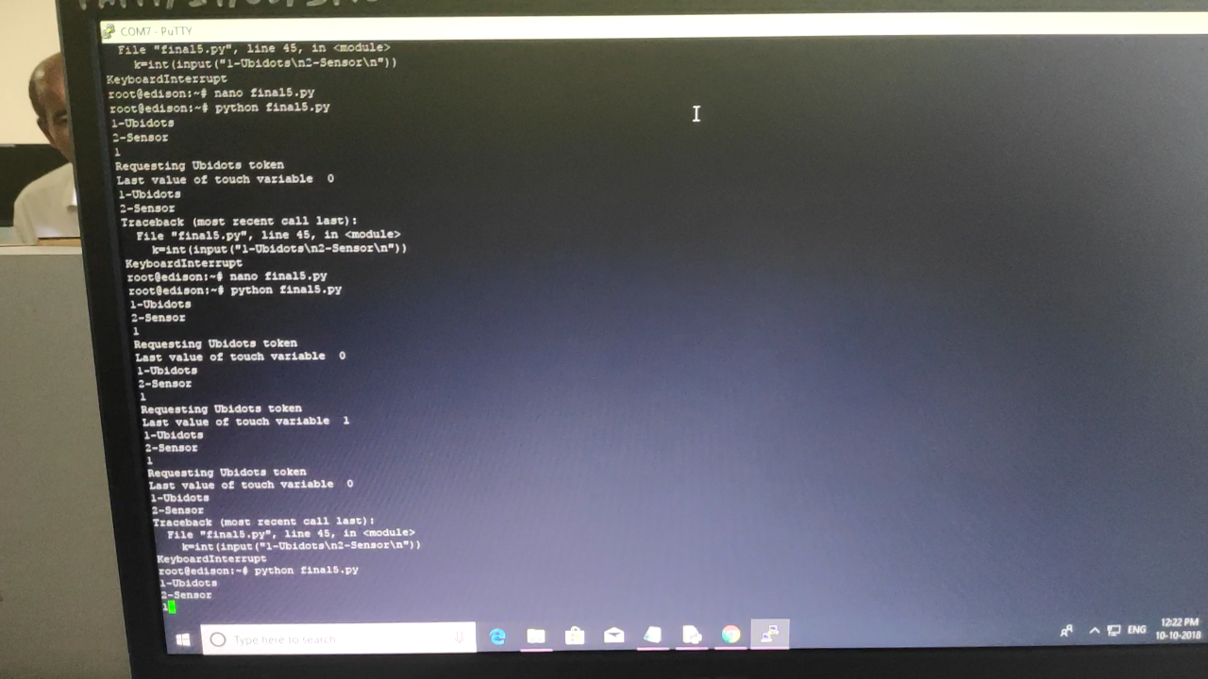

* Selecting Option as Ubidots.

1) By Turning On Button.

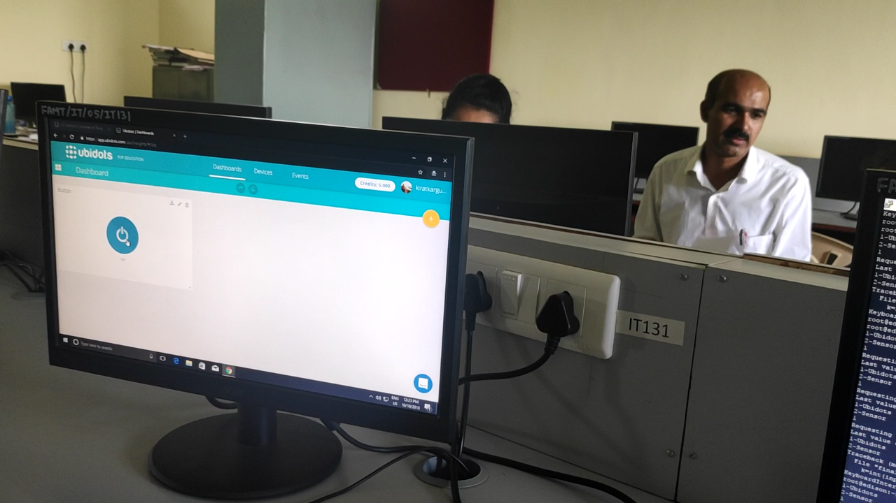

1. LED will be ON

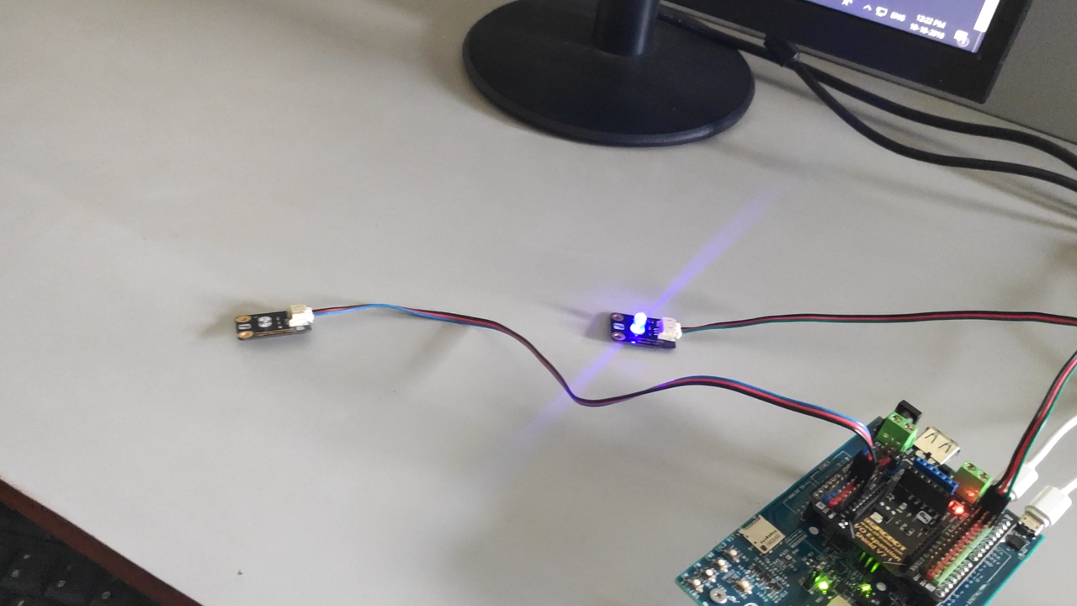

1. By Turning Off Button

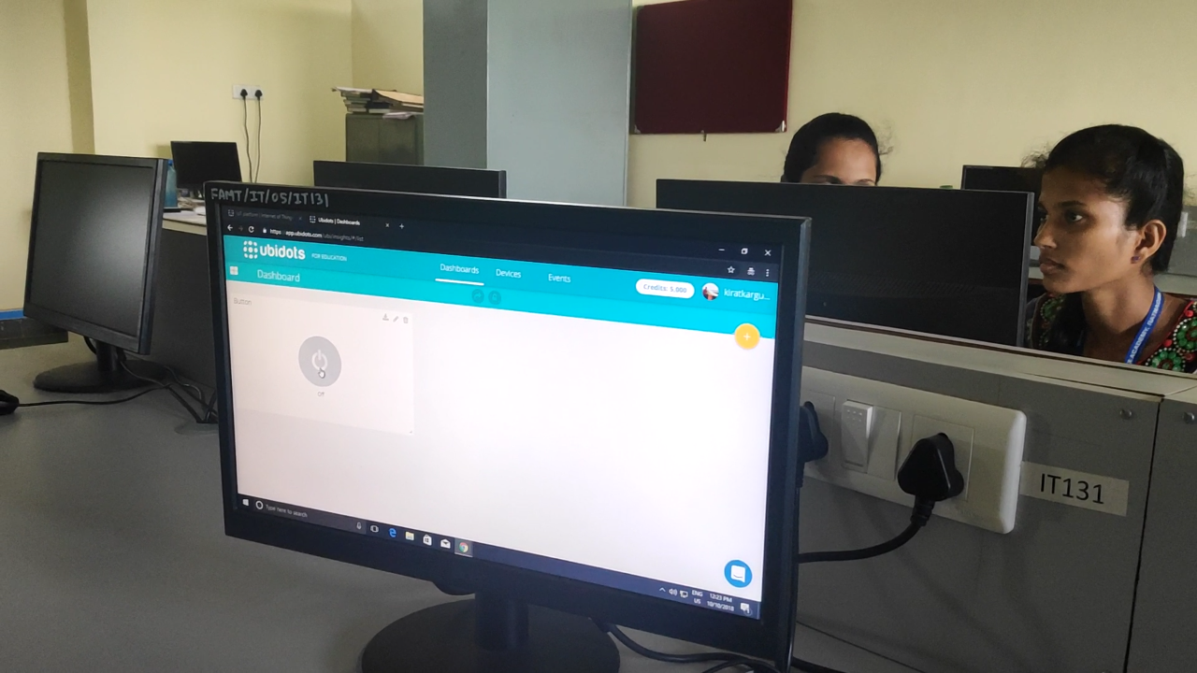

1. LED will be OFF

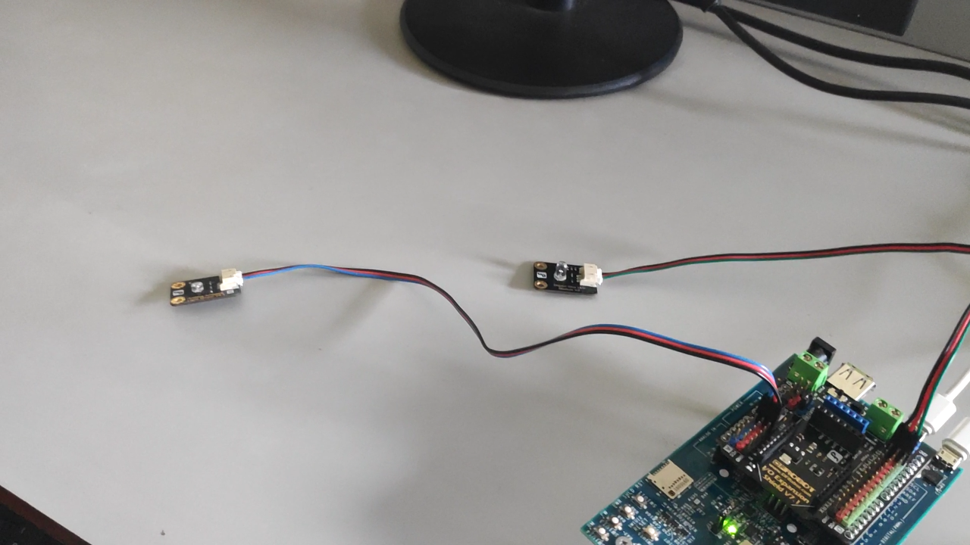

* Selecting Option as a Sensor

1. When there is darkness in room LED will ON

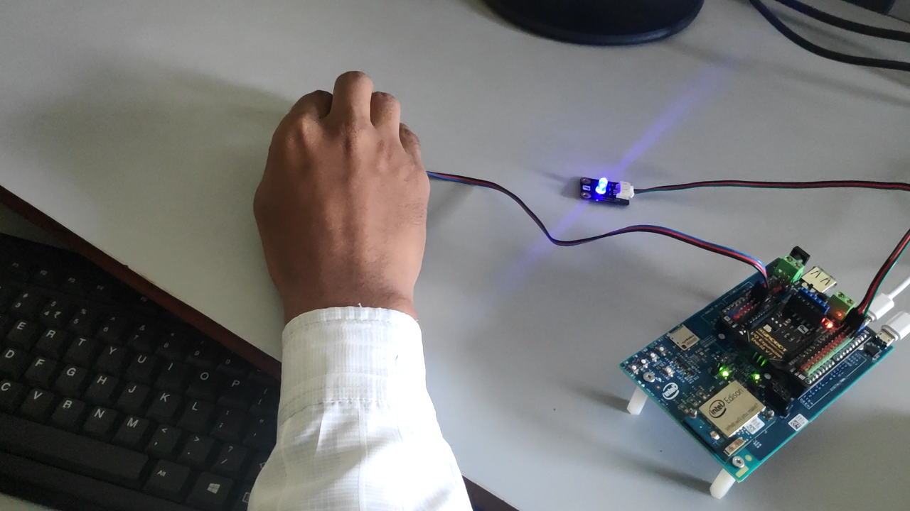

1. When there is Light in room LED will OFF

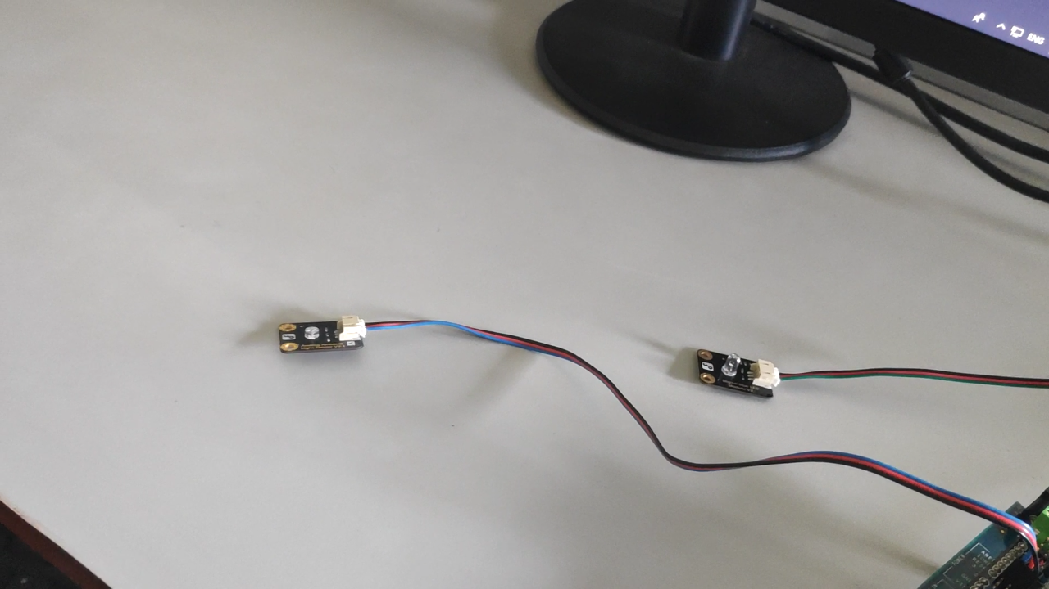

**Outcomes:**

* Studied Intel Edison Board
* Studied Light sensor
* Studied implementation of automatic light using light sensor and remotely .

**Conclusion :**

If the user chooses the Sensor Option then, when there is Sufficient amount of light in Room ,the light sensor does not glow LED . and when there is darkness in the room, the sensor will detect that and glow the LED.

If the user chooses the Ubidots Option then, when user remotely ON button at that time the LED will glow and when user will OFF the button at that time the LED will OFF.